**Analysis pipeline**

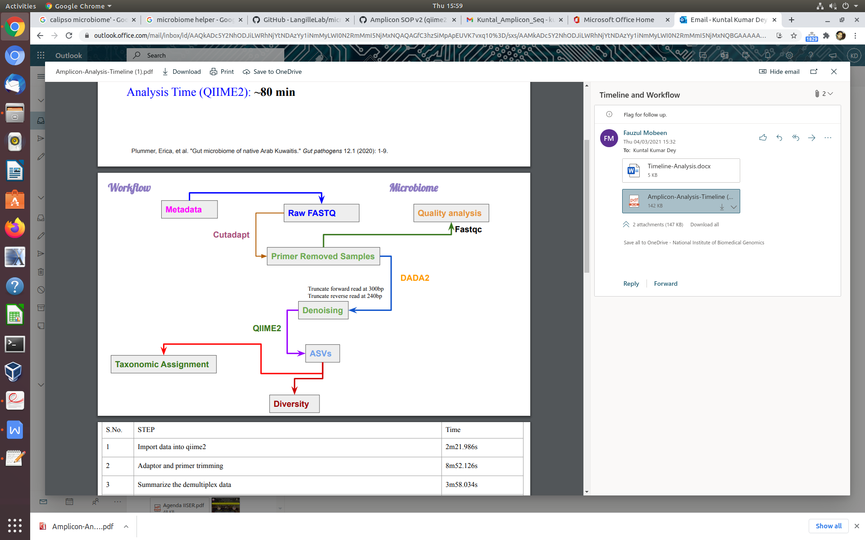

**Deliverable**

|  |  |  |
| --- | --- | --- |
| Sl No | Data | File Name |
|  | RAW DATA | Fastq files |
| A | QC data |  |
|  | Before | primer-trimmed-VL_16S_PE.qzv |
|  | After | denoising_stats.qzv |
| B | Identification of microbial comunity | taxa-bar-plots.qzv |
| C | Taxa Identification | classified_rep_seqs.qzv |
| D | Heatmap, abundance, analysis of dominant population | taxa-bar-plots.qzv |
| E | Rare fraction curve | alpha_rarefaction/rarefaction.qzv |
|  | Alpha diversity | core_metrics/evenness_group_significance.qzv  core_metrics/faith_pd_group_significance.qzv  core_metrics/observed_features_group_significance.qzv  core_metrics/shannon_group_significance.qzv |
| F | Comparetive analysis |
| G | Beta diversity | core_metrics/bray_curtis_emperor.qzv  core_metrics/jaccard_emperor.qzv  core_metrics/unweighted_unifrac_emperor.qzv  core_metrics/weighted_unifrac_emperor.qzv |
| H | Krona Chart | koronaplot/kronaplot.html |

**The basic requirements for Amplicon analysis using shotgun data**

**Information Required:**

1. Source of the Microbiome:
2. If host associated or culture then please mention the details of the host genome and also share the URL of the reference genome:
3. Please provide all the meta-data in a table (preferred .csv/.tsv) format given below, explicitly for which you want the comparison to be made.

|  |  |  |  |  |  |  |
| --- | --- | --- | --- | --- | --- | --- |
| Sample_Id | Sample_type | Group1 | Group...n | Condition | Location | Ecosystem |
| Sample_G I A | stool |  |  | 4 members  **Healthy**-khat chewers (daily) | Males  Age(35-44) | Human |
| Sample_G I B | Stool |  |  | 4 members  HBV **patients**- khat chewers (daily) | Males  (35-44) | Human |
| Sample_G I C | Stool |  |  | 2 members  HBV **patients**- khat chewers (4-6 times/week) | Females  (35-44) | Human |
| Sample_G II A | Stool |  |  | 4 members  HBV **patients**- **NON** khat (1-2 years)  Within a year of breast feeding | Females  (25-34) | Human |
| Sample_G II B | Stool |  |  | 3 members  HBV **patients**- **NON** khat (2-3 years quit) | Males  (25-34) | Human |
| Sample_ G II C | Stool |  |  | 4 members  HBV **patient**- khat chewers (daily)  High viral-load | Males  (25-34) | Human |
| Sample_ G III A | Stool |  |  | 4 members  **Healthy**- khat chewers (4-6 times/week) | Males  (25-34) | Human |
| Sample_ G III B | Stool |  |  | 4 members  **Healthy**- khat chewers (4-6 times/week) | Females  (35-44) | Human |
| Sample_ G III C | Stool |  |  | 4 members  **Healthy**- **NON** khat (more than 3 years) | Males  (35-44) | Human |
| Sample_ G IV A | Stool |  |  | 4 members  **Healthy**- **NON** khat (more than 3 years) | Females  (25-34) | Human |
| Sample_ G IV B | Stool |  |  | 4 members  **Healthy**- **NON** khat (more than 3 years) | Females  (35-44) | Human |
| Sample_ G IV C | Stool |  |  | 4 members  HBV **patients**- **NON** khat(1-2 years quit) | Males  (35-44) | Human |